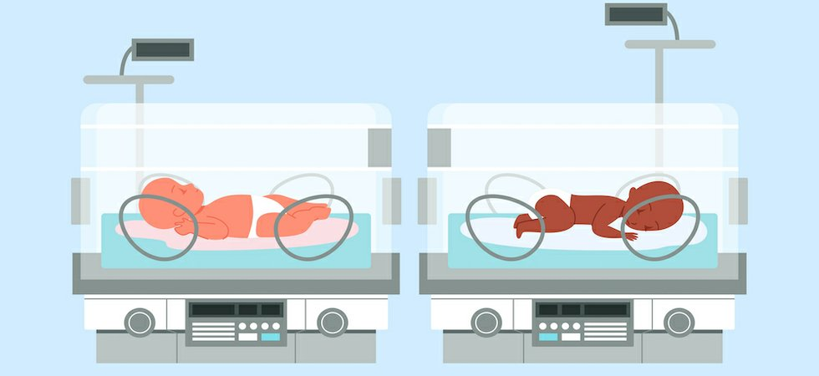Baby Incubator System

By: -

Mustafa Mohamed Kamal Ibrahim. (Team Leader)

Youssef Hussein Mahdi Ibrahim.

Mohamed Hany Maher Abdelsamei.

Mohamed Kamel Mohamed Abdelshakour.

Mohamed Mohamed Ali Elfeky.

MennaTullah Mohamed Shaaban Eid.

Mariam Reda Elsayed Mostafa.

Project overview

After a baby is born, sometimes the baby could be premature, sick or in need of TLC (Tender, Loving, Care).

This is why the baby may need to be in an incubator, some of the reasons are: -

Premature birth.

Breathing issues.

Infection.

Long or traumatic delivery.

Low birth weight.

Recovering from surgery.

An incubator is designed to provide a safe, controlled space for infants to live while their vital organs develop.

Unlike a simple bed, an incubator provides an environment that can be adjusted to provide the ideal temperature as well as the perfect amount of oxygen, humidity, and light.

Without this specifically controlled environment, many infants could not survive, particularly those born a few months early.

In addition to climate control, an incubator offers protection from allergens (مسببات الحساسية), germs, excessive noises, and light levels that might cause harm. An incubator’s ability to control humidity also allows it to protect a baby’s skin from losing too much water and becoming brittle or cracking.

An incubator can include equipment to track a range of things including a baby’s temperature and heart rate. This monitoring allows nurses and doctors to constantly track a baby’s health status.

Beyond just offering information about a baby’s vitals, an incubator will also either be open on top or have portal holes on the sides that allow it to be used in combination with various medical procedures and interventions.

Incubators can be used in combination with medical procedures like:

* feeding through an IV
* delivering blood or medications through an IV
* constantly monitoring vital functions
* ventilating

This means that not only does an incubator protect a baby, but it provides an ideal environment for medical professionals to monitor and treat an infant.

User Requirements

1. The system should facilitate the use of medical components so the nurse or doctor could operate on it without any problems or difficulties.
2. No one could use the system prior to being trained by a professional so that all unnecessary technical problems are avoided.
3. If a problem is encountered in the system the user could call a maintenance worker so that the problem is fixed as soon as possible.
4. The nurse or doctor could see all the vital signs of the child on a digital screen so that the required actions could be done hastily.
5. The system should be connected with a backup power supply so that if a power outage is encountered electricity problems are avoided.

Project Organization

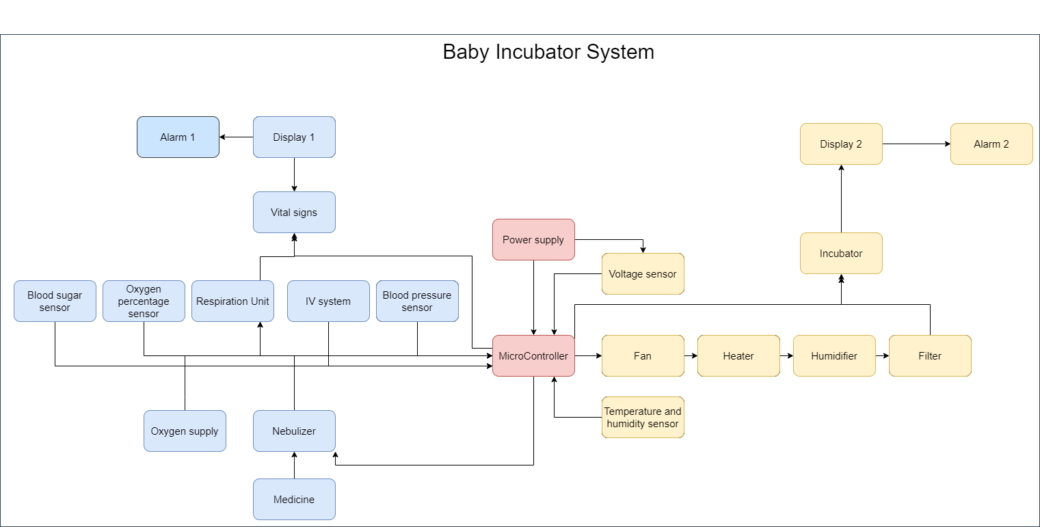

System requirements

**Functional requirements**:

1-The system shows correct readings from the sensors.

2-The system microcontroller acts upon all the system sensor readings so that all health risks for the baby could be avoided.

3-The system should rely on backup power supply if the incoming voltage is insufficient.

4-The system should be operated on by doctor, nurse or professional.

5-The system should be sure that all sensors work before putting in the baby.

6- The system should purify the incubator itself after a baby is removed from it and it doesn’t allow for adding a new baby in this time.

**Non-functional requirements**:

1-The system ready up the incubator to receive the baby in about 1 minutes after booting up.

2-The baby doesn’t enter the incubator unless the doctor examines him and says so.

3-The baby doesn’t leave the incubator unless it has full grown and in good condition according to the doctor.

4-The incubator is checked by the maintenance worker every month.

5-If the incubator has multiple faults in a single month, it must be replaced.

6-If the baby has fully grown and in good condition, the nurse calls his parent to notify him so that he could pick him up in a specified date.

Use case diagram

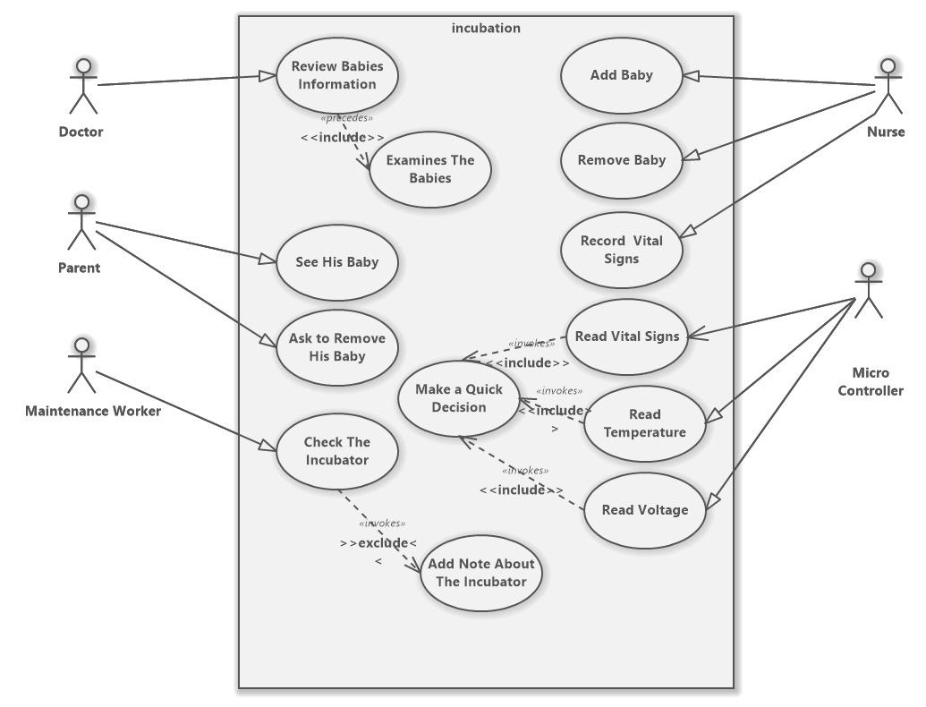

|  |  |
| --- | --- |
| **Use Case ID:** | 1 |
| **Use Case Name:** | Review babies Information |
| **Actors:** | Doctor |
| **Preconditions:** | 1: the babies must be in the incubation.  2: the nurse should have a baby report. |
| **Post-conditions** | 1: the doctor has all the information on the baby to facilitate diagnosis  2: the doctor examines the babies. |
| **Normal Flow:** | 1: the doctor is asking the nurse for information about the baby.  2: the nurse received the report for the doctor.  3: the doctor knows the child's condition and decides what to do with-it. |
| **Alternative Flows:** | in step 2 if the nurse doesn't have a report return to step 1 and doctor  asking again for the report. |

|  |  |
| --- | --- |
| **Use Case ID:** | 2 |
| **Use Case Name:** | See his baby |
| **Actors:** | Parent |
| **Preconditions:** | 1: parent asks the doctor to see the baby.  2: you are allowed to see the baby. |
| **Post-conditions** | parent saw the baby and checked him |
| **Normal Flow:** | 1: parent asks the doctor to see the baby.  2: doctor making arrangements for the parent.  3: parent can see the baby. |
| **Alternative Flows:** | in step 3 if the parent can’t see the baby return in another time to step 1 and to see again |

|  |  |
| --- | --- |
| **Use Case ID:** | 3 |
| **Use Case Name:** | Remove his baby |
| **Actors:** | Parent |
| **Preconditions:** | 1: the doctor must have allowed the baby’s release after his treatment.  2: parents must have the baby's exit arrangements from incubation. |
| **Post-conditions** | 1: the baby has become healthy.  2: parent has his baby. |
| **Normal Flow:** | 1: parent ask to take his baby.  2: doctor allow to release the baby.  3: baby's exit is done. |
| **Alternative Flows:** | in step 2 if the baby is not healthy, doctor has to disallow the removal and return to step 1. |

|  |  |
| --- | --- |
| **Use Case ID:** | 4 |
| **Use Case Name:** | Check the incubator |
| **Actors:** | Maintenance worker |
| **Preconditions:** | there's problem with the system |
| **Post-conditions** | The problem is solved. |
| **Normal Flow:** | 1: the maintenance worker checks the system  2: he tries to solve the problem  3: he solves the problem |
| **Alternative Flows:** | in step 2 if he doesn’t solve the problem, he makes a note about the cause of the problem so that he could bring the replacement later. |

|  |  |
| --- | --- |
| **Use Case ID:** | 5 |
| **Use Case Name:** | Add baby |
| **Actors:** | Nurse |
| **Preconditions:** | The parent has filled all the required information for the child. |
| **Post-conditions** | Baby is in the incubator. |
| **Normal Flow:** | 1: the nurse checks if the incubator is empty.  2: if it is empty, he/she turns on the incubator.  3: he/she puts the baby in the incubator. |
| **Alternative Flows:** | In step 2, if the incubator is occupied, the nurse checks another incubator, if all incubators are occupied, she refers to the doctor. |

|  |  |
| --- | --- |
| **Use Case ID:** | 6 |
| **Use Case Name:** | Remove baby |
| **Actors:** | Nurse |
| **Preconditions:** | The baby is in an incubator |
| **Post-conditions** | The doctor will tell the baby’s parent to complete the discharge procedures. |
| **Normal Flow:** | 1. The nurse checks on the baby. 2. The nurse will remove the baby. |
| **Alternative Flows:** | In step 1, if the baby is not healthy, the doctor tells the parent that the baby shouldn’t be removed and the baby should stay until it is healthy. |

|  |  |
| --- | --- |
| **Use Case ID:** | 7 |
| **Use Case Name:** | Sensor Control |
| **Actors:** | Microcontroller |
| **Preconditions:** | The microcontroller is connected to all the sensors. |
| **Post-conditions** | The microcontroller acts upon all sensors readings. |
| **Normal Flow:** | 1. The microcontroller reads the sensor readings. 2. It checks if a reading is activating an action. 3. The microcontroller displays all the sensor readings on the digital display. |
| **Alternative Flows:** | In step 1, if the sensor readings are faulty, the microcontroller activates an alarm and shows a warning on the screen. |

Activity diagram

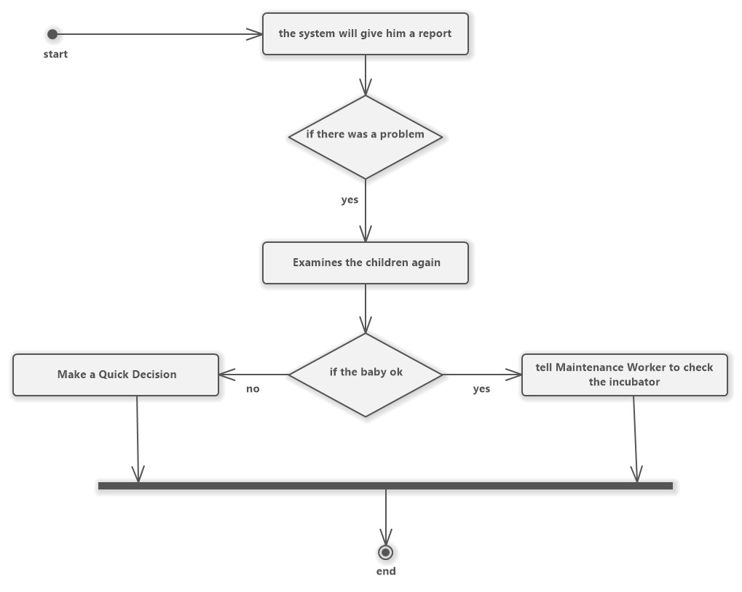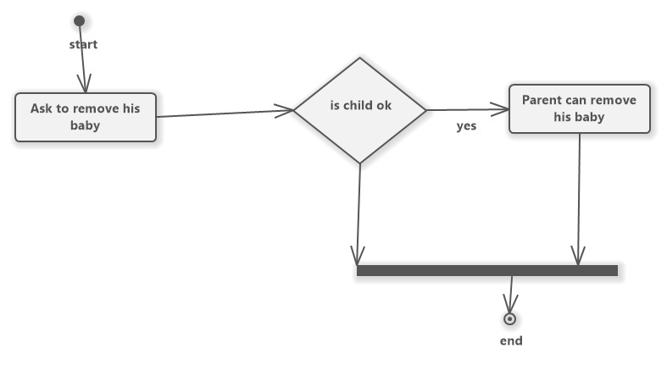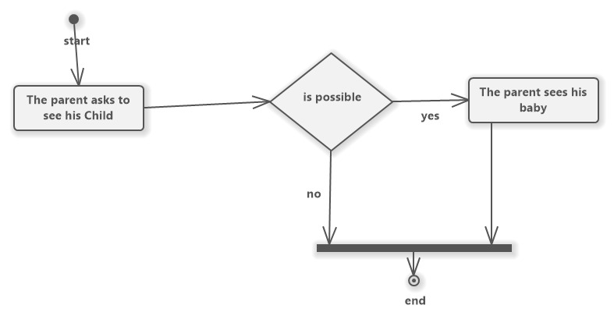

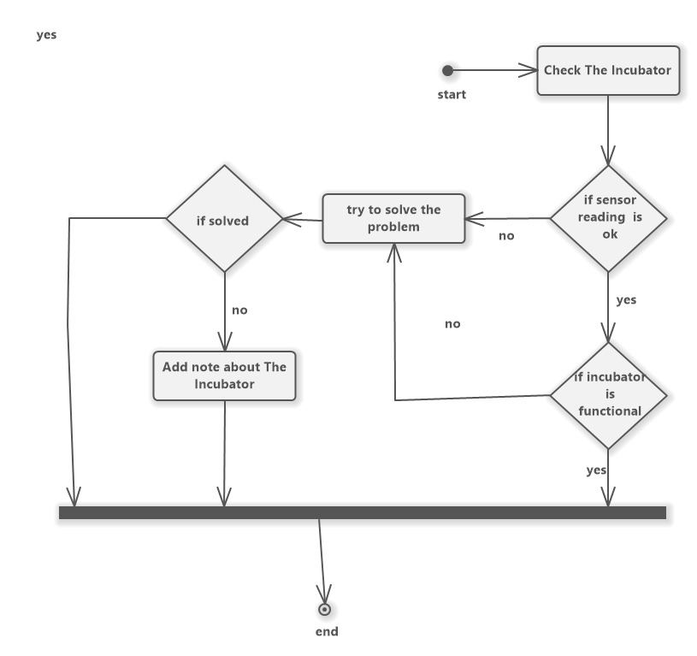

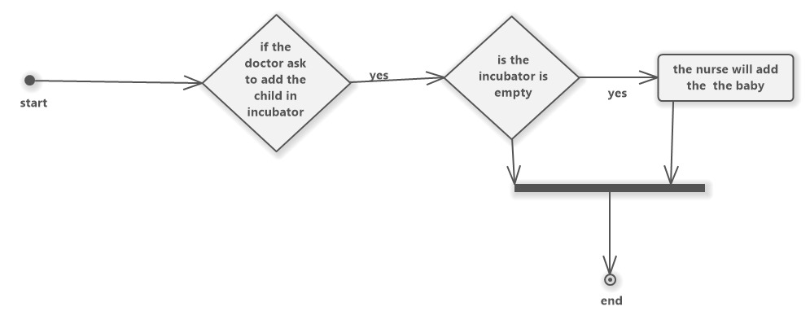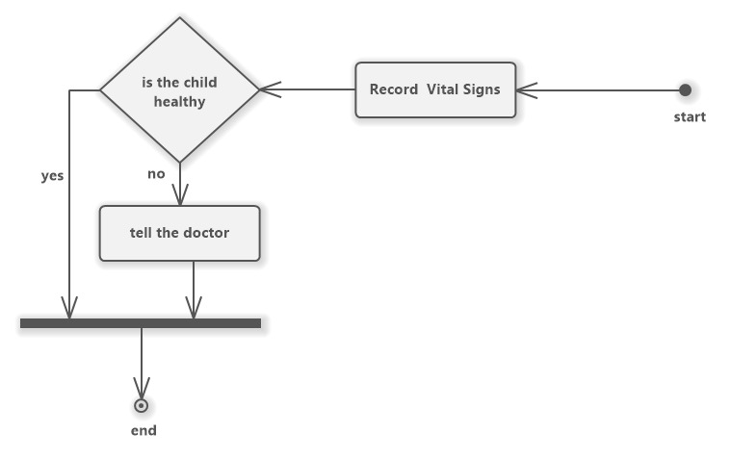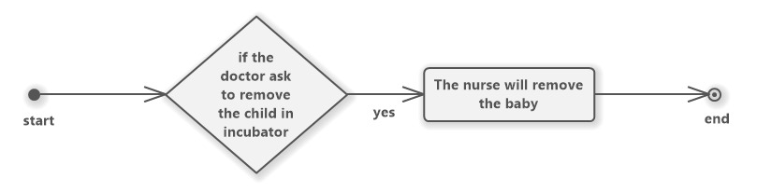

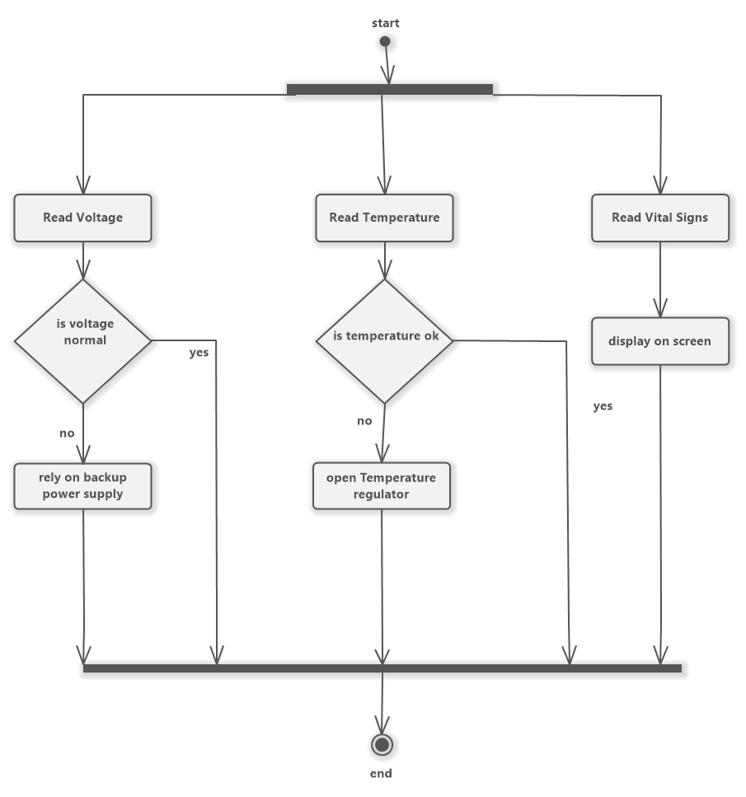Context diagram

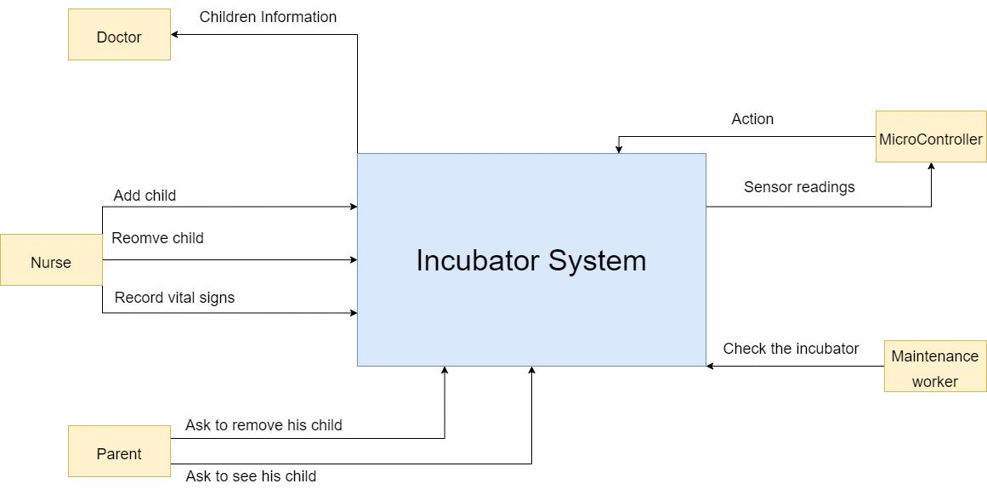

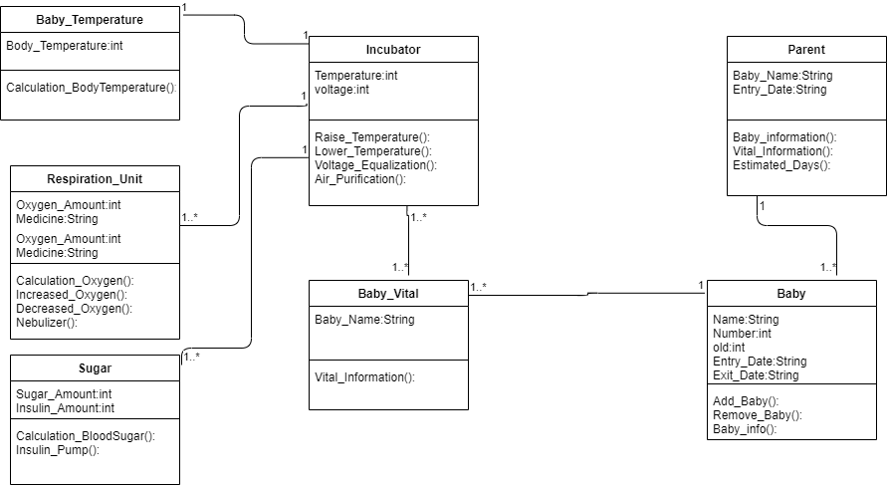Class diagram State diagram

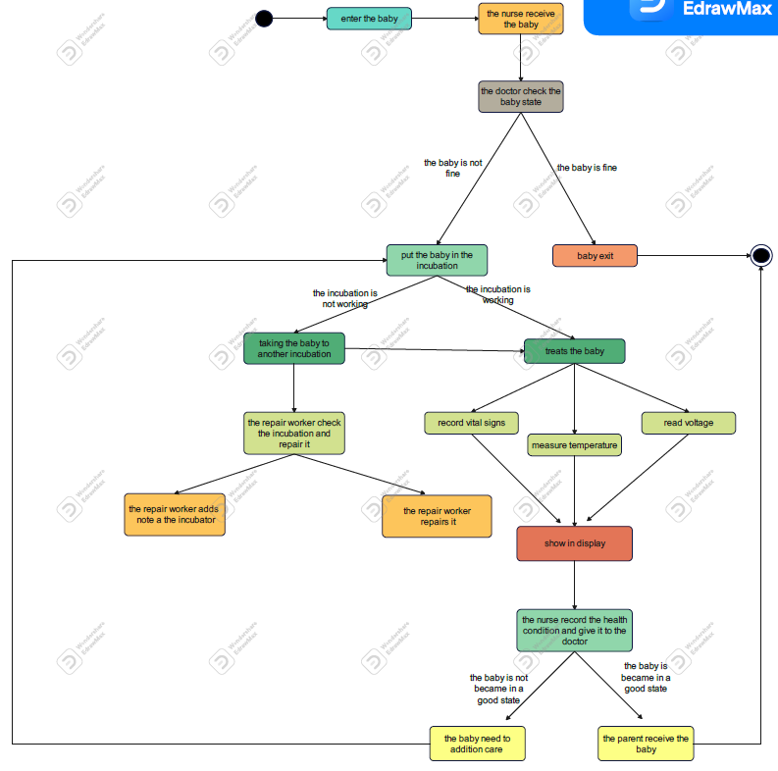

Components

-**1baby room:**

It is a closed box made of plastic by placing the newborn inside and containing the appropriate environment for him. This system contains openings that work to remove the air after a complete air cycle.

The baby room will be made from plastic box 1m X 1m with a removable lid.

-**2power source:**

The supply source is from the network with a voltage of 220 or 110 volts and a frequency of 60 or 50 hertz. This part also contains constant voltage outputs (dc) necessary to feed the electronic circuits that make up the device. The range of those voltages: 5 volts, 12 volts, 18 volts, 24 volts, according to the needs of the electronic circuit components.

-**3Control panel or front panel:**

Contains buttons to control the temperature, humidity and the amount of oxygen

It contains a display screen to display the numbers for each of the previous variants

It contains warning signs in different colors and according to the type of alert or warning

That is why this part is considered one of the most important parts of the device for the nursing staff, through which all variables can be adjusted according to need.

**4-heater (5V-12V ZVS induction heating coil):**

It was also presented that the purpose of using the incubator is to find a medium so that the medium is conditioned at an appropriate temperature, and this is the function of the heater.

We will use LM35 temperature sensor to know if the room is in an appropiate temperature.

**5-Bacterial Filter:**

It filters the air from bacteria and impurities, and it needs to be changed every 3 or 6 months as needed and according to the use of the device.

Gas filter Assembly GF-406.

**6-Nebulizer:**

It turns liquid medecine into a mist so that the baby needn’t to take it by the iv.

We will use a Mesh Nebulizer.

**7-IV (Intravenous) system:**

It provides the baby with all the nutrients and supplements that it needs throughout its journey to recovery.

**8-fan:**

Its function is to push the air into the nursery .

**9-Humidifier (Elecebe EB0048380):**

The function of this part of the device is to generate the required humidity, and its work depends on the evaporation of water in a calculated and accurate manner, so the water used must be clean and sterile.

We will use a DHT11 to check the humidity of the baby room.

**10-microprocessor:**

This part is the part that organizes the work of the device in an integrated way. It contains a program and it controls all the data entering and leaving the nursery. It receives information from the control circuits, performs the calculations and analyzes them, and then issues orders to those parts, especially the hydraulic ones, to ignite or stop.

We will use Raspery pi-4.

**11-Oxygen measurement unit:**

The phosphorous oxide solution is well sensitive to oxygen, so a chemical cell is used for this purpose, which is filled with phosphorous oxide gas for the purpose of sensitivity and converting the chemical reaction into a simple electric current that can know the amount of oxygen in the air.

We will use Air Quality sensor Breakout - CCS811 to check the oxygen level every 30 seconds.

**12-Respiration monitor unit:**

This unit relies on monitoring the child’s inhalation and exhalation movements and converting them into a current that obtains a light or signal with each inhale or exhale so that it issues an alarm when the number of breaths increases or decreases.

We will use Breath Controller HX710.

**13-Electricty sensor:**

This sensor is used to check high or low voltage to know if the incubator will need to rely on a backup power supply.

We will use MAX471 current and voltage Sensor to check the voltage and current every 30 seconds with a buzzer.

**14-Blood pressure sensor:**

This sensor is used to check the blood pressure of the baby.

We will use Shuian MAX30102 Heart Sensor.

Table of content

1. **Project Overview: - 2:4**
2. **User Requirements: - 5**
3. **Organization diagram: - 6**
4. **System Requirements: - 7:8** 
   1. **Functional Requirements.**
   2. **Non-Functional Requirements.**
5. **Use Case: - 9:15**
6. **Activity Diagrams: - 16:20**
7. **Context Diagram: - 21**
8. **Class Diagram: - 22**
9. **State Diagram: 23**
10. **Components: - 24:27**